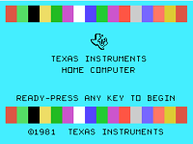 | VI99 for the TI-99 Computer  Brian Fox, Kilworth Ontario, Canada  Version 1.4 January 2023

What is VI99?
VI99 is provided as is with no warranty and may be freely distributed.
The original editor that still comes with the UNIX operating system is called vi (visual editor). VI99 is a partial replica of vi written for the TI-99 home computer. The current version of VI99 has an 8K buffer for the text files you want to edit and some vi commands are not available.
The vi99 editor is a 80 column screen editor and has two modes of operation:
- Command mode commands which cause action to be taken on the file, and
- Insert mode in which entered text can be inserted or overwritten into the file.
In the command mode, every character typed is a command that does something to the text file being edited; a character typed in the command mode may even cause the vi editor to enter the insert mode.
In the insert mode, every character typed is added to the text in the file; pressing the <Esc> (Escape) key turns off the Insert mode.
While there are a number of vi commands, just a handful of these is usually sufficient forroutine editing. This document shows vi99 commands that work in this version.
NOTE: VI99 is case-sensitive. Be sure not to use a capital letter in place of a lowercase letter; the results will not be what you expect.

No Operating System
Obviously VI99 does not have the UNIX operating system to run on. As a replacement vi99 lives on top of a Forth kernel. Forth gives you a simple interpreter that doubles as the command shell and also provides a soft landing if there is an program error.

The VI99 commands work from within the Forth command shell so you can return to VI99 instantly with the VI99 commands you know.

Quick Start

To Start vi99 on TI-99
    - Insert the Editor/Assembler Cartridge
    - Select Option 5
    - At the prompt type DSK?.VI9980 where ? Is the drive number where VI99 is located.

You enter the vi99 command shell.
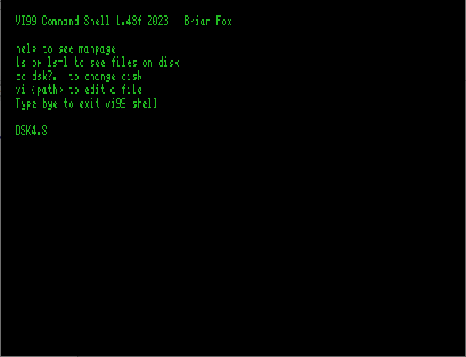
To use vi99 on a file, type: vi filename<enter>.
If filename does not contain a ‘.’ character the $HOME disk drive will be pre-pended to filename. $HOME contains the disk number that VI99 started from.
If the file exists, then the first page of the file will be displayed.
If the file does not exist, you get a file error and land back in the command shell.
If no filename is given VI99 starts up with an empty buffer to edit.
* | Vi [dskn.]filename | edit filename starting at line 1
 | vi | Purge the buffer and edit starting at line 1
 | // or edit | From Forth shell, resume editing current buffer

To Exit vi99

The fastest way to leave the editor is by pressing CTRL Z. This takes to back to the shell. The file is still in the buffer. To resume editing type edit <enter> .
Alternatively use the colon (:) command. This moves you to the bottom of the screen and waits for another command. The commands below are completed by hitting the <Enter> key.
* | :x <Enter> | quit vi, writing out modified file to file named in original invocation
 | :wq <Enter> | quit vi to the command shell. Changes are saved
 | :q <Enter> | quit vi to the command shell. Changes are saved
* | :q! <Enter> | quit vi to the command shell. Changes are NOT saved

Return to Home Screen

The bye command can be used in the colon line or from the VI99 shell.
* | :bye <Enter> | Return to the TI-99 startup screen

Command Mode

Moving the Cursor
Unlike modern editors, to move the cursor, you must use the key commands listed below. On some PC platforms, there are arrow keys but they are not mapped on VI99.
Since vi was designed with the “QWERTRY” keyboard containing no arrow keys so the arrow keys sometimes produce strange effects in VI99 and should be avoided.
If you go back and forth between a PC editor and a VI99, you may find that this dissimilarity in methods for cursor movement to be the most frustrating difference between the two.
*If a number is typed before cursor commands the cursor will move that amount.
Examples:
- 20l moves the cursor 20 chars to right
- 5k moves the cursor up 5 lines
* | j or <Enter> | move cursor down one line
* | k | move cursor up one line
* | h or <Backspace> | move cursor left one character
* | l or <Space> | move cursor right one character
* | 0 (zero) | move cursor to start of current line (the one with the cursor)
* | $ | move cursor to end of current line
 | 1G | Move cursor first line of file
 | G | Move cursor to last line of file
 | nG | Move cursor to line n

Screen Manipulation
The following commands allow the vi editor screen (or window) to move up or down several lines and to be refreshed. In the table below, the symbol ^ before a letter means that the <CTRL> key must be held down while the letter key is pressed.
 | ^f | move forward one screen
 | ^b | move backward one screen
 | ^d | move down (forward) one half screen
 | ^u | move up (back) one half screen
 | ^l | Redraws the screen
 | ^z | Return to the VI99 shell screen

Saving Files
These commands permit you to input and output files other than the named file with which you are currently working.
* | :w <Enter> | write current contents to file named in original vi call
* | :w newfile<Enter> | write current contents to a new file named newfile

Inserting or Adding Text
The following commands allow you to insert and add text. Each of these commands puts the vi editor into insert mode; thus, the <Esc> key must be pressed to terminate the entry of text and to put the vi editor back into command mode.
 | i | insert text before cursor, until <Esc> key
 | I | insert text at beginning of current line, until <Esc> key
 | a | append text after cursor, until <Esc> key
 | A | append text to end of current line, until <Esc> key
 | o | Open a line BELOW the cursor for insert editing
 | O | Open a line ABOVE the cursor for insert editing

Adding, Changing, and Deleting Text
Unlike PC editors, you cannot replace or delete text by highlighting it with the mouse. Instead use the commands in the following tables.

Change Text
The following commands allow you to modify text.
 | r | replace single character under cursor (no <Esc> needed)

Deleting Text
The following commands allow you to delete text.
 | x | delete single character under cursor
 | dd | delete entire current line, copy to buffer
 | ndd | delete n lines, copy to buffer

Cutting and Pasting Text
The following commands allow you to copy and paste text.
 | yy | copy (yank, cut) one line, the current line, into the “clip” buffer
 | nyy | Copy n lines from the current line down, into the clip buffer
 | p | Paste entire buffer into file

“COLON” Commands
If you press the ‘:’ key the cursor goes to the command line at the bottom of the screen.
After the colon you can enter commands that will go to the text interpreter.

 | :1G | move cursor to first line in file
 | :### G<Enter> | move cursor to line #  *WARNING* VI99 interpreter needs space between # and G
 | :$<Enter> | move cursor to last line in file

UHOH! You popped out of VI99

If you enter an unknown command after the colon don’t panic. You will see an error message and you will just pop back to the command shell.

To restart VI99 in the current buffer you are editing just type: edit <enter>

Alternate: // <enter>

Command Shell Commands

Think of the command shell like the a rudimentary UNIX shell program. It gives you the ability to run some other programs.

Type :q or :q! To get to the command shell.

Items in square brackets below are optional

vi
 | vi | Start vi with an empty buffer
 | vi [dsk1.] filename | Edit filename

See the disks
 | ls-l [dskn.] | View the contents of
 | ls [dsk1.] | Same as dir

Miscellaneous
 | COLD | “COLD boot vi99. Restart like it was just loaded.
 | bye | exit vi99 and return to TI splash screen

